**Modern Half Curved Wall Shelf**

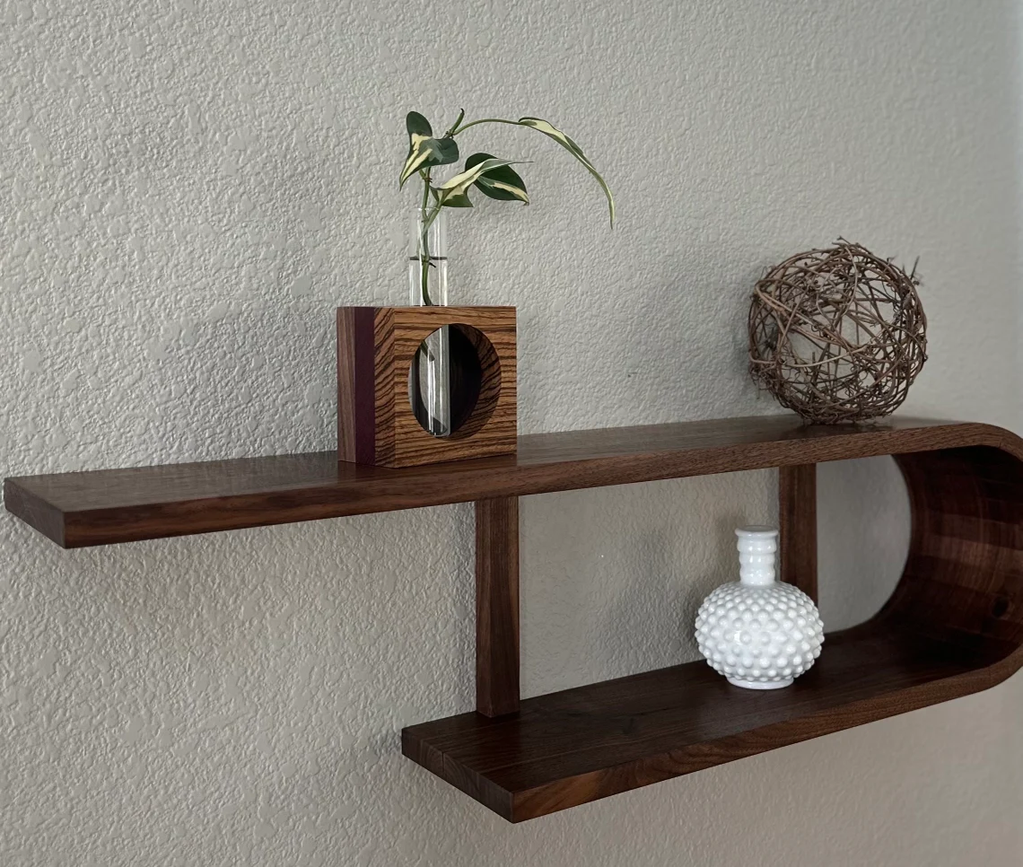 A Modern Half Curved Wall Shelf is a sleek and elegant storage solution that adds a unique touch to any contemporary space. Designed with a smooth, half-circle curve, this shelf creates a dynamic, flowing aesthetic that contrasts with traditional straight-edged shelves. Made from materials like wood, metal, or acrylic, it provides a modern and minimalistic look while offering practical storage for books, plants, or decorative items. Ideal for living rooms, bedrooms, or hallways, the half-curved design helps to soften the lines of a room, creating a more inviting and stylish atmosphere. This shelf not only serves a functional purpose but also serves as a striking design element in your home.